**DAILY ONLINE ACTIVITIES SUMMARY**

|  |  |  |  |  |  |  |  |  |
| --- | --- | --- | --- | --- | --- | --- | --- | --- |
| **Date:** | **21/05/2020** | | | | | **Name:** | **Hanan Saleem Baji** | |
| **Sem & Sec** | **4th SEM 'A' Section** | | | | | **USN:** | **4AL18CS024** | |
| **Online Test Summary** | | | | | | | | |
| **Subject** | | **Microcontroller and Embedded Systems** | | | | | | |
| **Max. Marks** | | **30** | | **Score** | | | **21** | |
| **Certification Course Summary** | | | | | | | | |
| **Course** | **1. Python In Machine Learning** | | | | | | | |
| **Certificate Provider** | | | **1.Great Learning Academy** | | **Duration** | | | **1. 2 hours** |
| **Coding Challenges** | | | | | | | | |
| **Problem Statement: 1.** Write a C program to construct a singly linked list by removing duplicate elements in the sorted linked list.   1. Write C program to create Singly Linked List with n elements and reverse the elements using C. 2. Write a C or Java program to implement FCFS and SJF process scheduling. 3. We have a letter or a word then we need add some letters to it and need to find out shortest palindrome. 4. Printing the odd and even numbers using thread. | | | | | | | | |
| **Status: completed** | | | | | | | | |
| **Uploaded the report in Github** | | | | | **yes** | | | |
| **If yes Repository name** | | | | | 1. <https://github.com/saleemhananbaji/C-coding> 2. <https://github.com/saleemhananbaji/Java-coding> | | | |
| **Uploaded the report in slack** | | | | | **yes** | | | |

ONLINE TEST DETAILS: Online test was conducted on the first module of Microcontroller and Embedded Systems. Test contains 30 questions of 1 Mark each.

Snapshot:

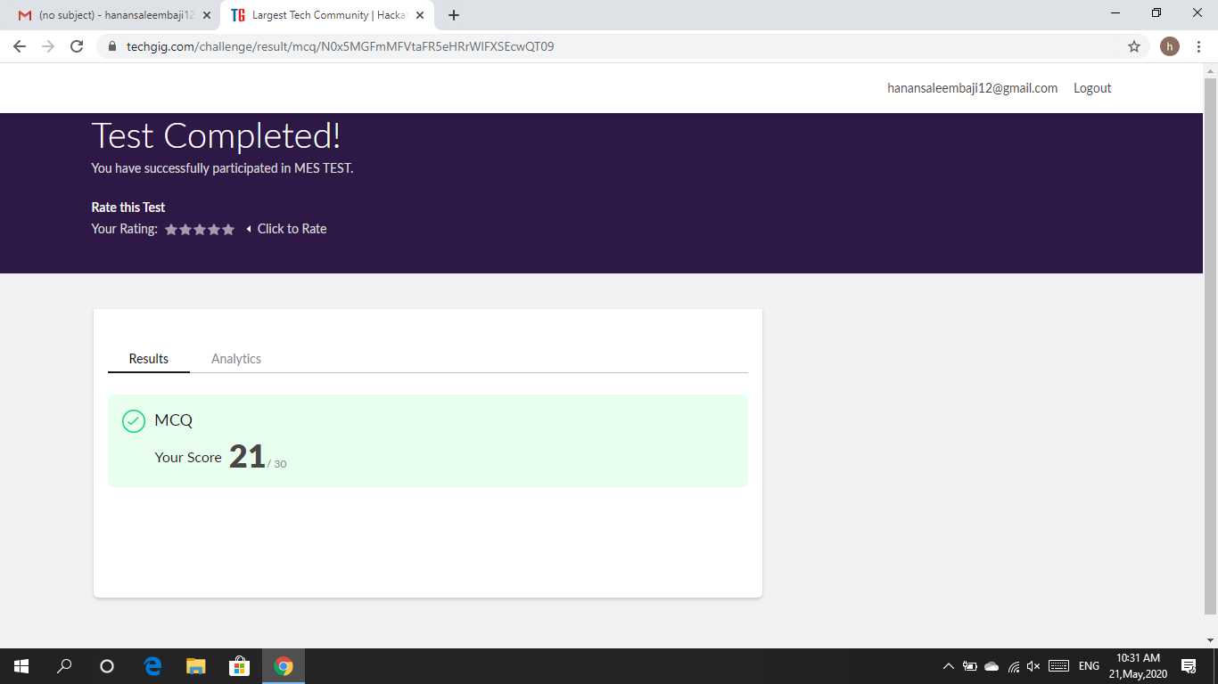

Certification Course Details: As the continuation of Python In Machine Learning certification course, I was able to complete the intiation of Pandas series and Dataframes, Saving and loading dataframes in Python.

Snapshot:

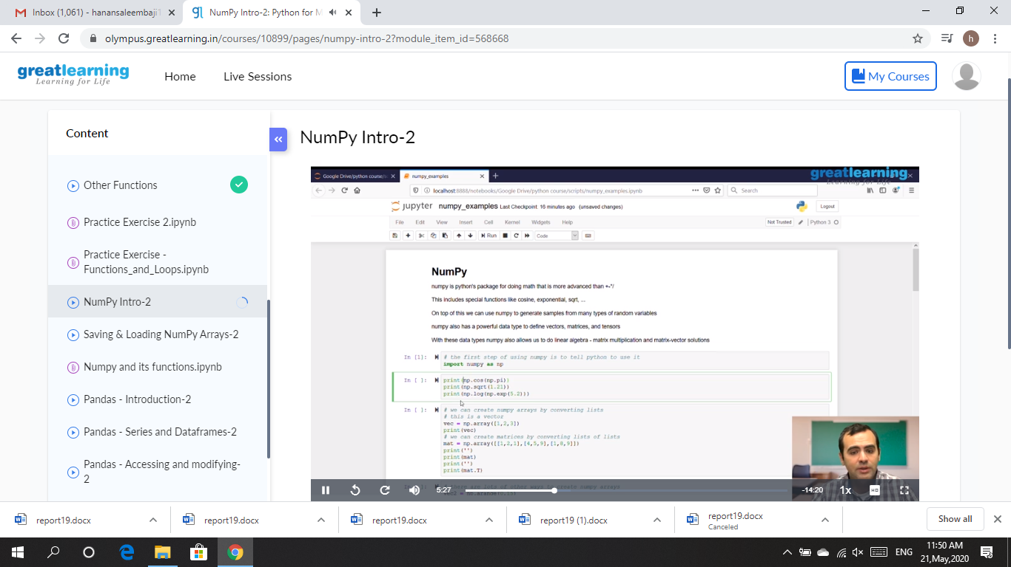

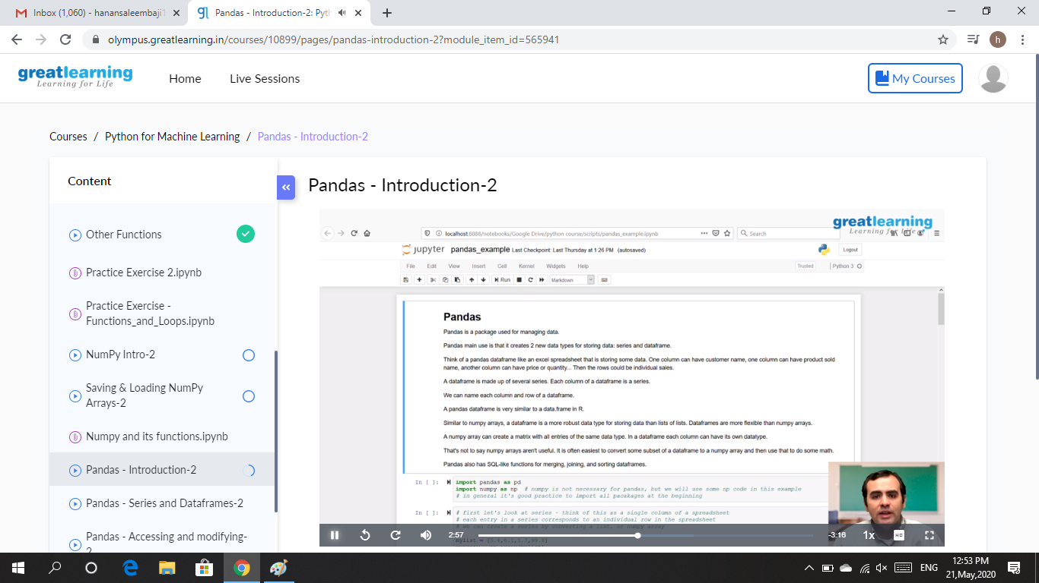

CODING CHALLENGES DETAILS: Problem statements

1. Write a C program to construct a singly linked list by removing duplicate elements in the sorted linked list

Description:

Take a sorted list and traverse the list. Compare the current node element with next adjacent node. If it is same then delete second element, if not retain. Finally print the resulting list.

Sample output:

Given list {1,2,2,3,3,3,4}

Resulting list{1,2,3,4}

Solution : Uploaded it in github

Snapshot:

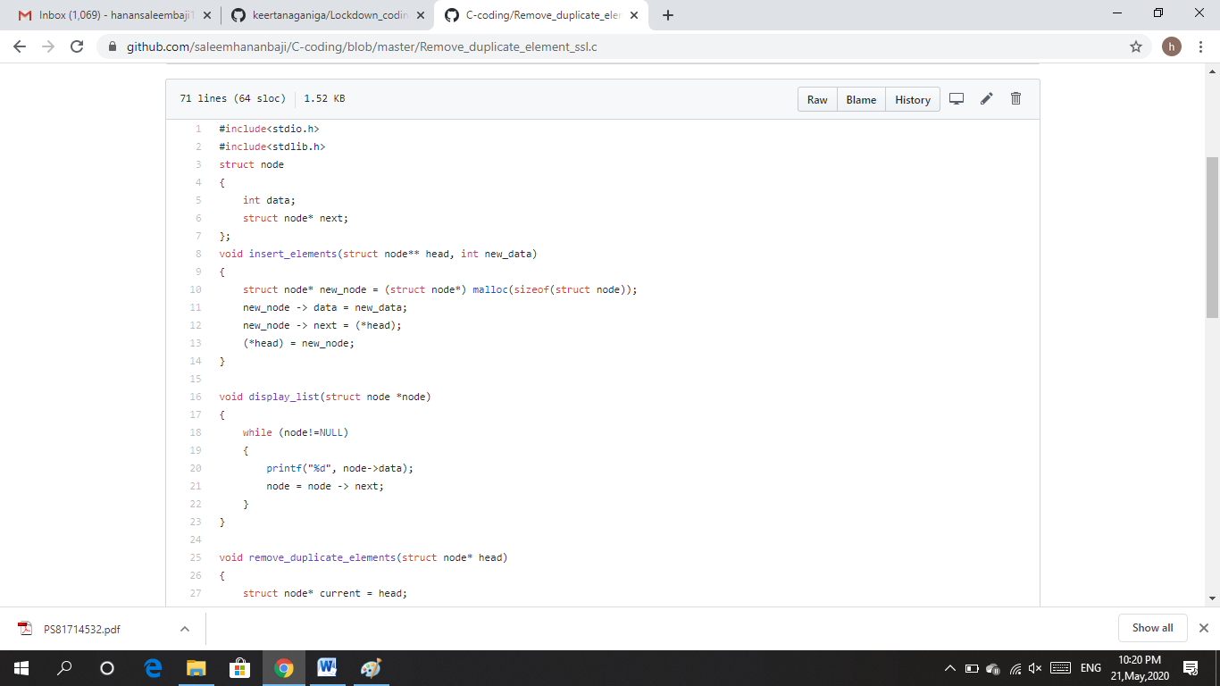

1. Write C program to create Singly Linked List with n elements and reverse the elements using C.

Hint: Create the SLL, and then Reverse the link in SLL until Head becomes NULL. Each time Reversing the link, Head must be moved to next immediate node.

Solution : Uploaded it in github

Snapshot:

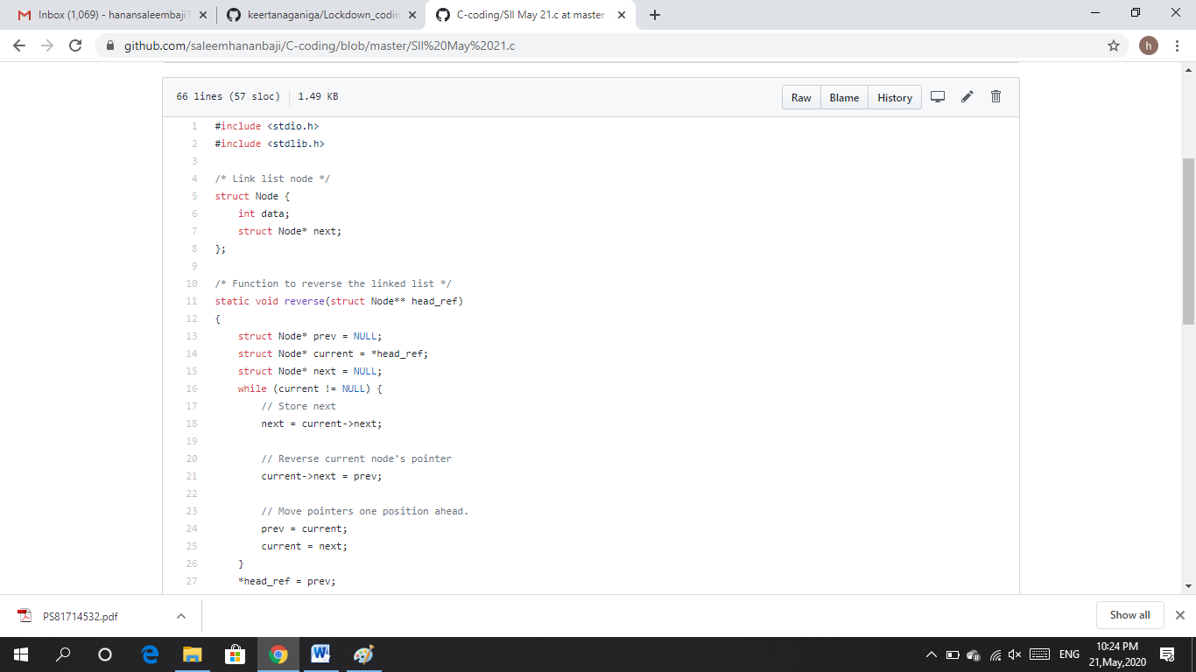

1. Write a C or Java program to implement FCFS and SJF process scheduling.

Input: Processes with burst time

Output: Process being scheduled

Solution : Uploaded it in github

Snapshot:

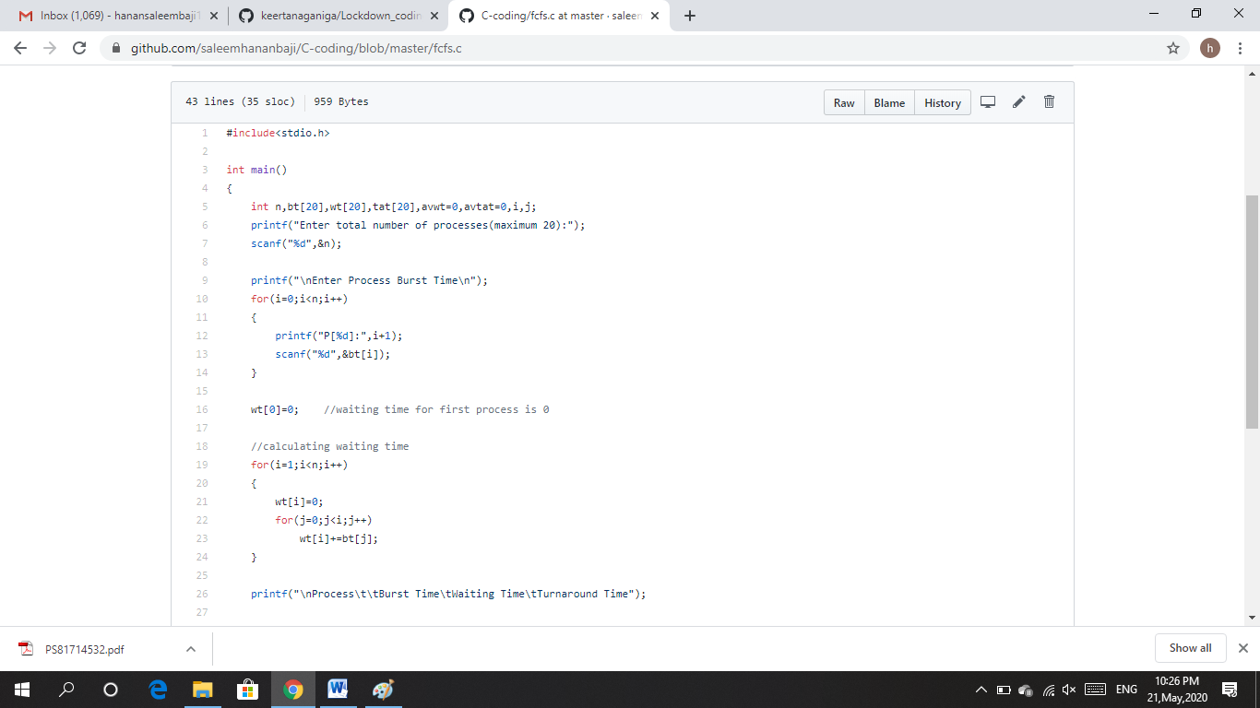

1. We have a letter or a word then we need add some letters to it and need to find out shortest palindrome.

For example we take “S”: S will be the shortest palindrome string.

If we take “xyz”: zyxyz will be the shortest palindrome string.

So we need to add some characters to the given string or character and find out what will be the shortest palindrome string by using simple java program.

Solution : Uploaded it in github

Snapshot:

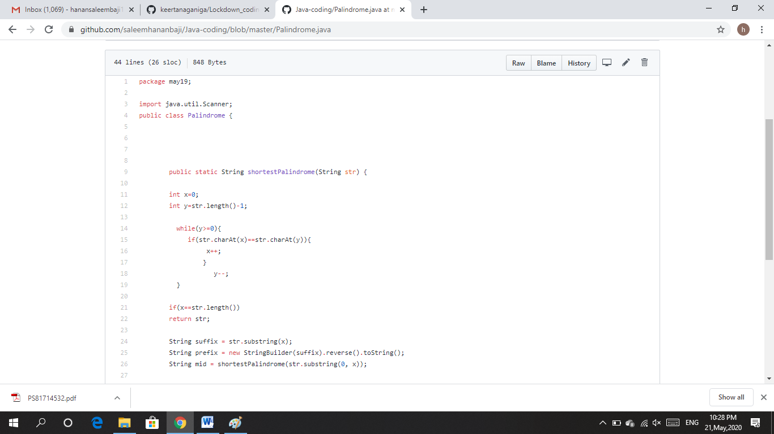

1. Printing the odd and even numbers using thread.

Solution : Uploaded it in github

Snapshot:

